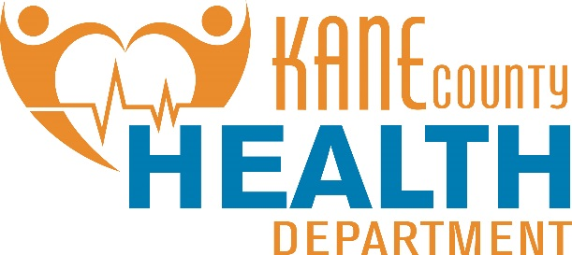

Michael Isaacson, MPH

Executive Director

1240 N. Highland Ave. Aurora, Illinois 60506

Main Number:

630.208.3801

Website:

[www.kanehealth.com](http://www.kanehealth.com/)

1750 Grandstand Place

Elgin, IL 60123

**July 5, 2022 Beat the Heat in Kane County:**

The National Weather Service has issued an Excessive Heat Warning for Kane County beginning at 0324 on Tuesday, July 5th and ending at 11pm on Thursday, July 7th. During this time, the heat index is anticipated to reach between 106 and 108 degrees Fahrenheit. Extreme heat and humidity can substantially increase the risk of heat related illness. Find tips below for staying cool! In the event individuals lack air conditioning please visit the Kane County website at CountyofKane.org & KaneHealth.com for an updated listed of cooling centers near you!

*Stay Cool*

• Stay in air-conditioned buildings such as Kane County cooling centers.

• Do not rely on a fan as your primary cooling device.

• Limit outdoor activity, especially midday when it is the hottest part of the day, and avoid direct sunlight.

• Wear loose, lightweight, light-colored clothing.

• Take cool showers or baths to lower your body temperature.

• Check on at-risk friends, family, and neighbors at least twice a day. These may include seniors and people with chronic health conditions.

*Stay Hydrated*

• Drink more water than usual and don’t wait until you’re thirsty to hydrate.

• Drink two to four cups of water every hour while working or exercising outside.

• Avoid alcohol or beverages with high amounts of sugar.

*Stay Informed*

• Check the local news for extreme heat warnings.

• Visit kanehealth.com/Pages/Heat.aspx for heat related information.

Normally, the body cools itself by sweating. However, if temperatures and humidity are extremely high, sweating is not effective in maintaining the body’s normal temperature. If the body does not cool properly or does not cool enough, a person may suffer a heat-related illness, which can become serious or even deadly if unattended. Warning signs and symptoms vary but may include:

**Heat Exhaustion** *Symptoms*

• Heavy sweating

• Weakness

• Skin cold, pale, and clammy

• Weak pulse, fainting and vomiting

**What You Should Do**

• Move to a cooler location

• Lie down and loosen your clothing

• Apply cool, wet cloths to as much of your body as possible

• Sip water

• If you have vomited and it continues, seek medical attention immediately

**Heat Stroke** *Symptoms*

• High body temperature (above 103 degrees F)

• Hot, red, dry or moist skin

• Rapid and strong pulse

• Possible unconsciousness

**What You Should Do**

• Call 911 immediately – this is a medical emergency

• Move the person to a cooler location

• Reduce the person’s body temperature with cool cloths or a bath

• Do NOT give fluids

People most vulnerable for heat-related illness include the elderly, those who work or exercise outdoors, infants and children, the homeless or poor, and people with a chronic medical condition.

The Illinois Department on Aging encourages relatives and friends to make daily visits or calls to senior citizens living alone. When temperatures and humidity are extremely high, seniors and people with chronic health conditions should be monitored for dehydration and other effects of extreme heat. Additionally, seniors should eat lighter meals, take longer and more frequent rests, and drink plenty of fluids.

Never leave anyone, including pets, alone in a closed, parked vehicle. The air temperature inside a car rises rapidly during hot weather and can lead to brain damage or death.

Go to [www.kanehealth.com/Pages/Heat.aspx](http://www.kanehealth.com/Pages/Heat.aspx) for more heat safety information.